1. Update the following code so that the values in array b is ‘x’ more than the corresponding values in array a. You can only write only one line of code inside the loop (in the comment section marked “Write Code Here”). Do not modify anything else. (10)

int n = 10;

int x = 5;

int index = 0;

int a[] = {12, 7, 3, 71, 2, 43, 38, 23, 45, 22};

int b[n];

for (int i=0; i<n; i++) {

//Write Code Here

}

1. char s = “america”

What is wrong with this C statement. Mark the errors and fix them. (4)

1. Suppose you want to declare an array of size 15 and the elements of the array will be in a geometric progression, the first one starting with 1 and the common ratio being 2. For example, the first few elements of that array will be 1, 2, 4, 8, 16 , … and so on. Write a for loop to initialize the array with the required progression. (10)

1. To declare a string, Fahim uses the following code. What will happen in the second and the third statement. Explain. (10)

char a[10];

a[0] = 98;

a[1] = 97;

a[2] = 'n';

a[3] = 'a';

a[4] = 'n';

a[5] = 'a';

a[6] = ‘\0’;

1. Consider the following code.

char a[10];

char ch = ‘a’;

for(int i = 0; i<8;i++)

{

a[i] = ch+8-i;

}

a[8] = ‘\0’;

What will be stored in the given character array ‘a’ of the question after the execution of the block of code? (10)

1. How much bytes does an int type array with 12 elements take in memory? (10)

1. What does lexicographical comparison mean? Explain with examples. How can we order strings in lexicographic order in C? (10)

1. What does ASCII value of a character mean? How can you print the ASCII value of a character in C language? (10)
2. Explain Bubble Sorting. Suppose you are given an array of integers 12, 7, 9, 1, 3, 73, 11, 15, 62, 19, 4. What will be the sequence of these integers if we run Bubble sort for only 5 iterations? (10)
3. How can you find the sum of digits of a number? Write a C program that will extract the digits of the given integer number as input and add them to find the required output. For example, if the input is 1235623, then the output will be 22. Because, 1+2+3+5+6+2+3 = 22. (6)
4. You will be given a 3x3 matrix as input. You need to check whether the matrix is a magic square or not. Magic squares are the matrices which have equal sum along all rows, columns and diagonals. For example,

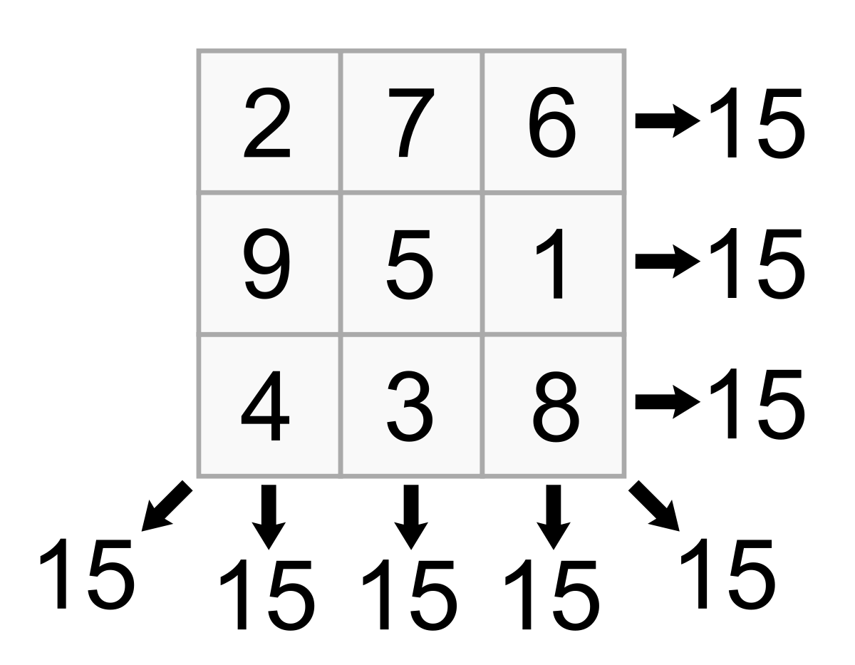

This is a magic square as you can see all the sums are equal to 15 along all the rows and columns and even the diagonals.

Now,Write a C Program to check the matrix is magic square or not. (10)

| **Sample Input** | **Sample Output** |
| --- | --- |
| 2 7 6  9 8 1  4 3 5 | NO |
| 2 7 6  9 5 1  4 3 8 | YES |